Meet Keir Graff!
He will be visiting our school on Friday, November 22nd. Mr. Graff is the author of three middle-grade novels, including the The Matchstick Castle and The Phantom Tower! You can learn more at www.keirgraff.com. If you would like signed copies of his work, please return this form with payment by Wednesday, November 20th.

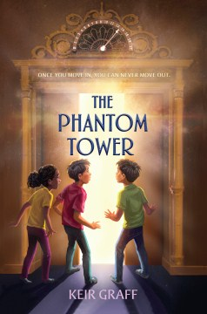  "[A] nail-biting adventure. . . . Hand to fans of Eoin Colfer's 'Artemis Fowl' novels, Roland Smith's 'IQ' series, or Mac Barnett's 'The Brixton Brothers.'"--School Library Journal | The Phantom Tower  Colm and Mal are identical twins--their own mom can't tell them apart, but they're different in just about every other way. Neither brother is excited to be moving to Chicago for a fresh start with their mom just after their dad's death. But nothing cures homesickness like intrigue--and their new home, Brunhild Tower, has plenty of it: mysterious elderly neighbors who warn against wandering the building at midday, strange sounds in the walls, and an elevator missing a button for the thirteenth floor.  One day, that button appears--and when the doors open on the missing floor, the boys are greeted by the strangest puzzle yet: a twin building that is stuck in time and bustling with activity. All of Brunhild Tower's former residents live on in this phantom tower, where the rules of the real world don't apply. But when the brothers and their newfound friends discover they're  trapped by an ancient curse, they must band together before it's too late. | Hardcover book  $16.70 | Personalized to:
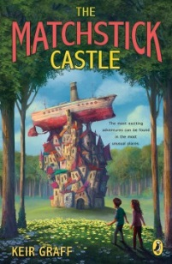  “This quirky novel is reminiscent of a Wes Anderson movie for the tweenage set. For those who enjoy a bit of absurdist humor with their realism.” School Library Journal | The Matchstick Castle  Brian can think of quite a few places he'd rather spend his summer than with his aunt and uncle in Boring, Illinois. Jail, for example. Or an earplug factory. Anything would be better than doing summer school on a computer while his scientist dad is stationed at the South Pole.  Boring lives up to its name until Brian and his cousin Nora have a fight, get lost, and discover a huge, wooden house in the forest. With balconies, turrets, and windows seemingly stuck on at random, it looks ready to fall over in the next stiff breeze. To the madcap, eccentric family that lives inside, it’s not just a home it’s a castle. | Paperback book  $8.80 | Personalized to:
ORDERS DUE by Wednesday, Nov 20th. | Cash or Check (payable to “The Book Stall ”) enclosed Price reflects a 10% discount off the cover price.
Thank You! |  |  | Total:

Student’s Name: _______________________ Teacher’s Name: ______________________

