Coonley 4th Grade Motorized Toy Maker Day
While students may not complete their toy on this day it will be a dedicated work time with adult assistance.

Wednesday, May 16th from 1:00 -2:30 PM
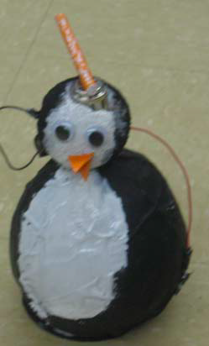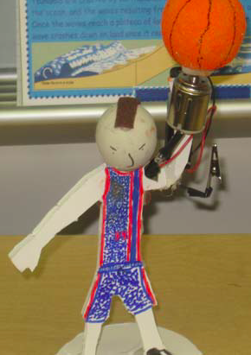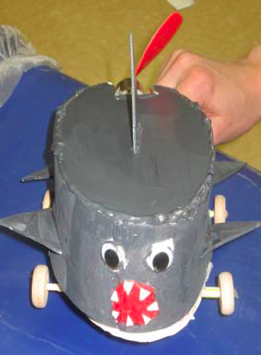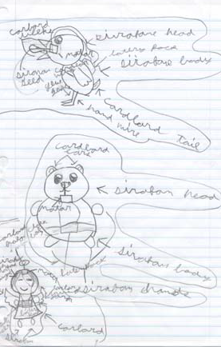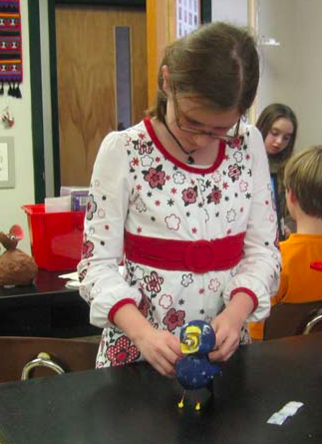

Parents needed to help students make their toy designs. We need parents to man the following maker rooms.
- 306 - Hot Gluing Room - Help students as they hot glue items on their toys.
- 304 - Painting Room - Help students paint their toys.
- 303 - Foam Core Cutting Room - Help or cut out students’ patterns in foam core board.
- 301 - Wood and Wire Room - with problem solving stations

If you are interested in volunteering please email Ms. Malhiot at kmmalhiot@cps.edu and Ms. Lezotte elezotte@cps.edu to let us know so we can plan for a successful day.

If you have a hot glue gun we can use for the day, please let us know.

Thank you for your help - This should be an amazing maker day for students to see their creative toy designs come to life.

